**Movies-CRUD Application**

### Document Properties

| Item | Details |
| --- | --- |
| Document | Architecture Design Document |
| Application | Movies-CRUD Application |
| Author | Karthika karthikeyan |
| Version | V1.0 |
| Creation Date | 05Sep2020 |
| Last Updated | 07Sep2020 |
| Status | Completed |

Contents

Document Properties 1

**1.** **Introduction** 3

**2.** **Architecture Diagram** 3

**3.** **Use-Case View** 3

**4.** **Flow Chart** 5

**5.** **Components** 6

**6.** **Services** 6

**7.** **Validations** 6

**8.** **Tools and Libraries** 6

**9.** **Unit Testing** 7

**10.** **Responsive** 7

**11.** **Accessibility** 7

**12.** **Theming** 7

**13.** **Setup** 7

# **Introduction**

This document provides a comprehensive architectural overview of the application, using number of different architectural views to depict different aspects of the application.

# **Architecture Diagram**

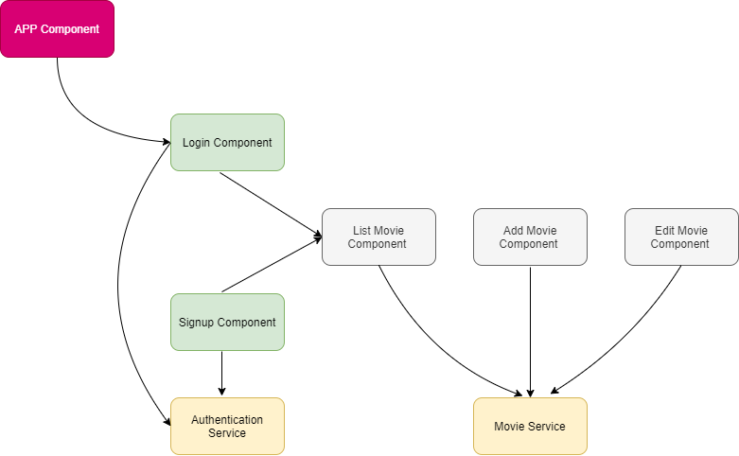

# **Use-Case View**

The application use cases are –

* **Login** – It allows user to logged in to perform the actions like to perform crud operations
* **Registration** – If user is not existing, We can register the user to perform crud operation
* **Add Movies** – It provide functionality to add movie.
* **Edit Movie –** Any movie can be editable while clicking on edit button.
* **Delete Movie** – Each movie will have a delete icon, the movie can be deleted by clicking on delete button

These use cases are initiated by the user.

# **Flow Chart**

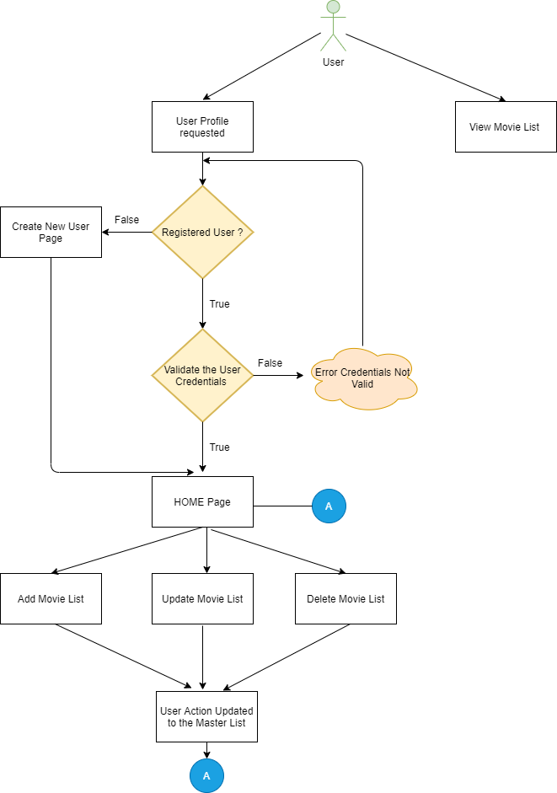

# **Components**

* AppComponent – This component is used for Application Bootstrapping
* ListMoviesComponent – Home Page of application that show all the list and their respective movies with edit and delete feature and links for adding new movies.
* AddMovieComponent – This component contain form for add movie.
* EditMovieComponent – This component contain form for edit movie.

# **Services**

There are three services –

1. MovieService – This service generally having logic about movie in the application and this contain code for getting movie list, edit movie details, add new movie and delete movie logic.
2. AuthService – This service generally having logic about login into the application and this contain code for Registration logic.
3. JsonServer – Used db.json for performing all the tasks

# **Validations**

1) Application covered the required validation for login and movie.

2) Application having validation for login user whether they have the login details or not

**Validation strategy:**

- Reactive form for validation

- There is corresponding html template for form elements

- Required attribute true for individual form element, this can be extended to have in a separate service file for re-usability.

# **Tools and Libraries**

- Angular version: 10.0

- TypesScript: 3.9

- Rxjs: 6.5

- Jest – 26.0.13

- ngrx – 10.0

# **Unit Testing**

Added Unit Test cases for components.

It consists of component-

* + header.component.spec.ts – It contain test cases for the all the logic for header component
  + Login Component, Sign-up component, Movies module, auth.services

**Screenshot for unit test cases –**

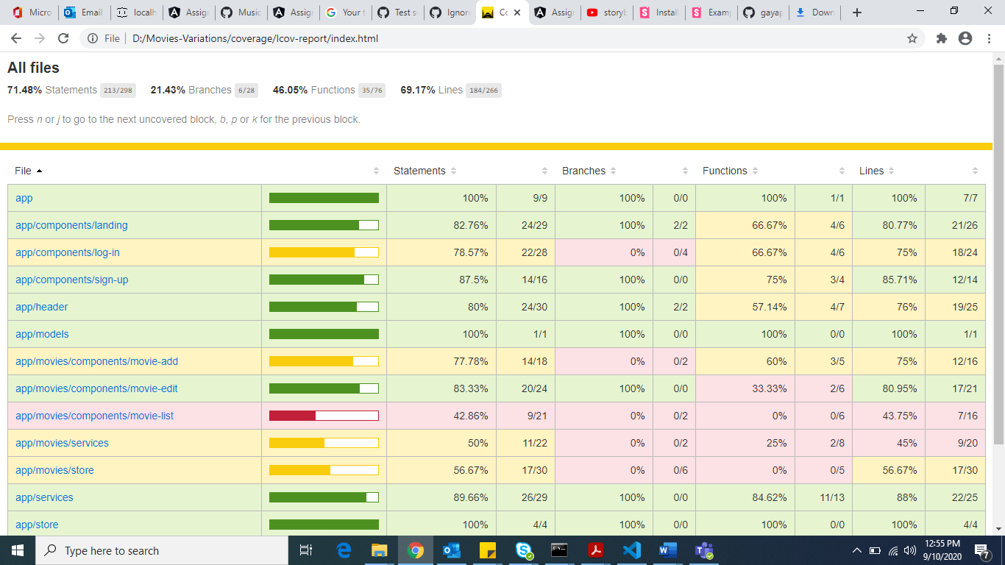

# **Storybook**

I have developed the storybook for all components.

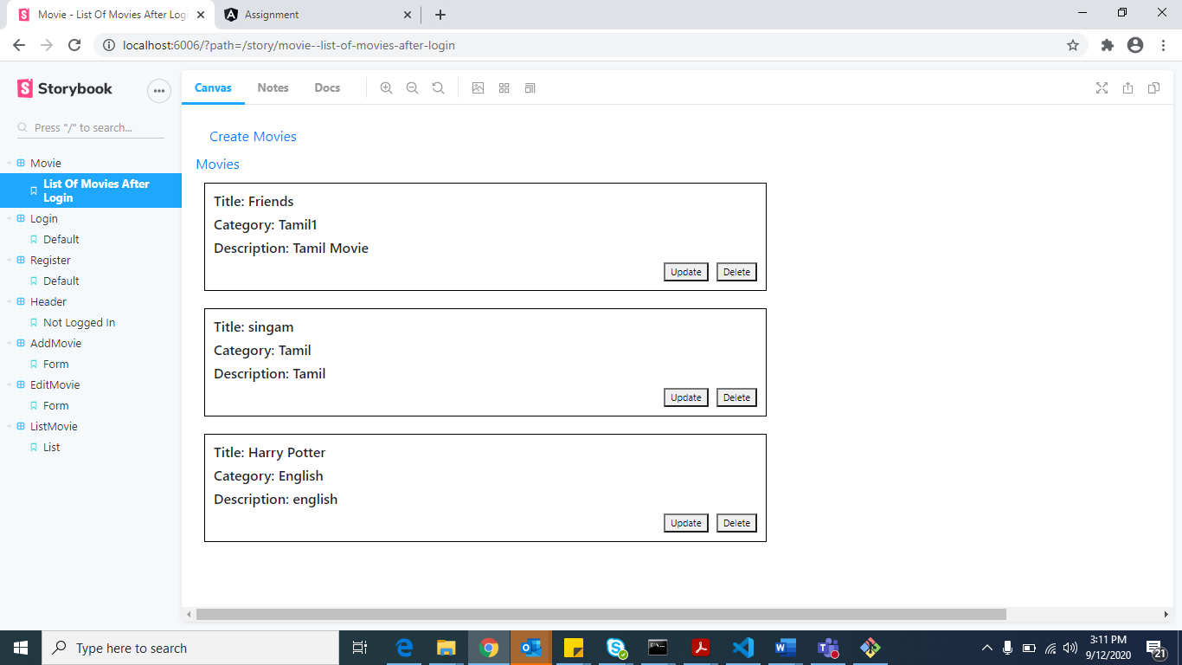

# **Responsive**

* The application is responsive with all the device and desktop size.
* No Horizontal scrollbar in application.
* Used SCSS for designing.

# **Accessibility**

For Accessibility, application having appropriate HTML tags that are preferred for accessibility

User can run application via keyboard and tab.

# **Theming**

I have done the theming for login page.

# **Setup**

1. Download and install node.js (version: 12.16)
2. Install npm and install @angular (version: 9.0)
3. Git clone <https://github.com/karthikakarthikeyan/TaviscaAssignment1> origin master
4. json-server --watch db.json
5. Navigate to cloned folder & run npm install
6. Run ng serve
7. Run the Stroybook : npm run storybook